Lesson 1
Trigonometric Functions

sPECIFIC OBJECTIVES:
At the end of the lesson, the student is expected to :
- Define trigonometry.
- Measure angles in rotations, in degrees and in radians.
- Find the measures of coterminal angles.
- Change from degree measure to radian measure and from radian measure to degree measure.
- Define the six trigonometric functions.
- Identify the relations derived from Pythagorean Theorem.
- Find the values of the six trigonometric functions of special angles.
- Define the trigonometric functions of complementary angles.
1.1 Trigonometry

Definition 1.1 Trigonometry

Trigonometry is the branch of mathematics that deals with the measurement of triangle, that is, the sides and angles of a triangle. Trigonometry was derived from two Greek words trigonon, which means triangle and metron, which means measurement.

Remarks:

Trigonometry plays important role in the continuous development of astronomy, physics, mechanics, navigation, surveying and other fields.

1.2 Angle
Definition 1.2 .1 Angle

An angle is defined as the amount of rotation to move a ray (a halfline with an endpoint) from one position to another. The original position of the ray is called the initial side of the angle, and the final position of the ray is called the terminal side. The point about which the rotation occurs and at which the initial and terminal side of the angle intersect is called the vertex.

Remarks:

When the vertex of an angle is the origin of the rectangular coordinate system and its initial side coincides with the positive x-axis, the angle is said to be in the standard position.

Terminal
Side

Vertex
Initial Side

The sign of an angle is determined by the direction of rotation of the initial side. If the rotation from the initial to terminal side is in counterclockwise direction, the angle measure is positive, and if the rotation is in clockwise direction, the angle measure is negative.

Initial Side

Terminal
Terminal Side
Side
Initial Side

Positive Angle Negative Angle

Definition 1.2.2 Angle Measurement

Angles can be measured in degrees, radians or grads. One rotation measures 360°, 2 radians, or 400 grads.

There are three methods of measuring angles. These are:
- Sexagesimal system where the basic unit is degree (1°). The degree can be further divided into 60 equal parts called minutes, and each minute can be divided into 60 equal parts called seconds.
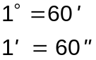
- Revolution system where the angle measure is given as the number of rotations from the initial side to the terminal side.
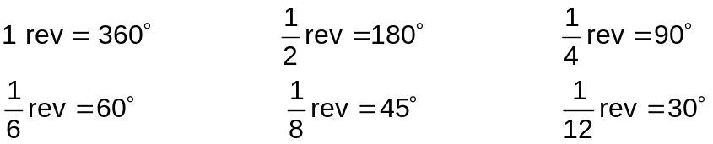

- Radian system where angle measure is in radians. A radian (rad) is the angle that intercepts an arc equal to the radius of the circle.

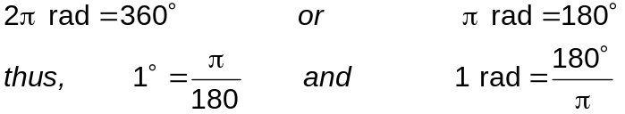

Remarks:

- To express a given number of degrees in radians, multiply the number of degrees by 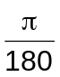.
- To express a given number of radians in degrees, multiply the number of radians by 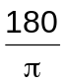.

Example 1.2.1 Convert the following angles measured in degrees, minutes and seconds to angles measured to the nearest hundredth of a degree:

a) 64°24’ 38” c) 145° 11’ 56”
b) 228° 23’ 10” d) 356° 09’ 34”

Example 1.2.2 Convert the following angles measured in degrees to angles measured to the nearest minute:

a) 56.39° c) 323.28°
c) 273.8° d) 163.18°

Example 1.2.3 Find the degree measure of the angle for each rotation:
a) 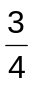 rotation, counterclockwise c) 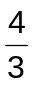 rotation, counterclockwise
b) 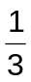 rotation, clockwise d) 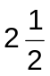rotation, clockwise

Example 1.2.4 Express each angle measure in degrees:

a) 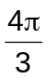 d) 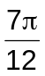
b) 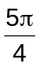 e) 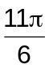
c) 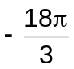 f) 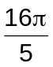

Example 1.2.5 Express each angle measure in radians. Give answer in terms of .

- 120° d) 28°
- 335° e) 1035°
- -310° f) 450°

Definition 1.2.3 Coterminal Angles

Coterminal angles are angles in standard position whose initial and terminal sides are the same.

Remark:

To find angles coterminal to a given angle, add or subtract multiples of 360° to it.

Example 1.2.6 Draw the following angles and find two angles (one positive and one negative) coterminal with each.

- 55° c) 153°
- 70° d) 219°

Example 1.2.7 For each of the following angles, find a coterminal angle with measure such that 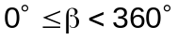.

- -100° c) 900°
- 524° d) 1250°

1.3 Classification of Angles

Angles are classified according to the measurement of its angle.

- Zero Angle – an angle formed by two coinciding half-line (rays) without
rotation between them.

- Acute angle (0r sharp) – an angle formed between 0° and 90°.

- Right Angle – is a 90° angle. Angle formed by two perpendicular half-lines.

- Obtuse Angle (Blunt) – angle formed between 90° and 180°.

- Straight Angle – an angle whose measure is exactly 180° .It is formed by
two-half lines extending in opposite directions.

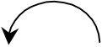

- Reflex (Bent-Back) – angle formed between 180° and 360°.

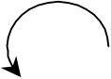

1.4 Triangle
Definition 1.4 Triangles

Triangles are polygon having three sides.

1.5 Kinds of Triangles

Kinds of triangle according to the measure of its angle:
- Right Triangle – triangle with a right angle
- Oblique triangle – triangle with no right angle.
* Acute triangle – triangle having three acute angles
* Obtuse triangle – triangle with an obtuse angle.

Kinds of triangle according to the measure of its sides:
- Scalene triangle – triangle with no equal sides
- Isosceles triangle – triangle with two equal sides
- Equilateral triangle – triangle with all three sides equal

1.6 The Trigonometric Functions

The trigonometric functions are sine (sin), cosine (cos), tangent (tan), cotangent (cot), secant (sec) and cosecant (csc).

Consider the right triangle ABC, with right angle at C.

B

a c

C b A

By taking the ratios of the sides of the triangle, the trigonometric functions of the acute angle A are as follows

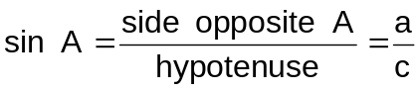

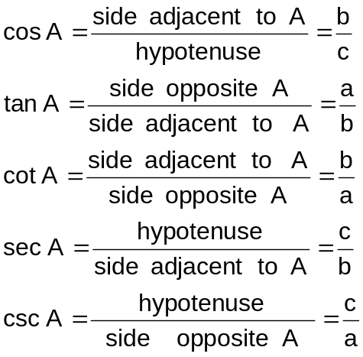

Example 1.6 Draw the right triangle whose sides have the following values, and find the six trigonometric functions of the acute angle A:

a) a = 5 , b = 12, c = 13 c) a = 6 , b = 8 , c = 10

b) a = 12 , b = 9, c = 15 d) a = 1 , b = 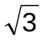 , c = 2

1.7 Reciprocal Functions
The following gives the reciprocal relation of the six trigonometric functions.
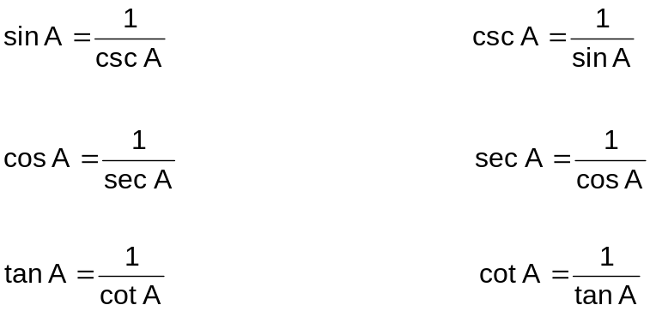

1.8 The Pythagorean Theorem
Definition 1.9 The Pythagorean Theorem

The Pythagorean theorem states that the square of the hypotenuse is equal to the sum of the squares of the other two sides. In symbol, using the ΔACB as shown,
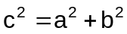

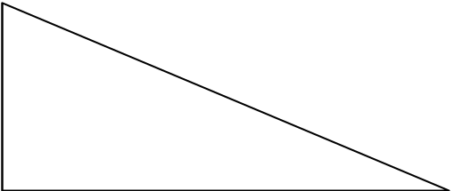

B

c
a

A
C
b

Example 1.8.1 Each of the following is a point on the terminal side of an angle in standard position. Determine the value to four decimal places of all six trigonometric functions of the angle.

a) 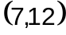 c) 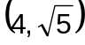
b) 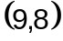 d) 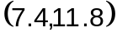

Example 1.8.2 Find the other five functions of the acute angle A, given that::

a) 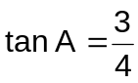 c) 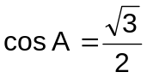
b) 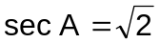 d) 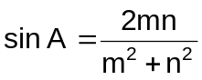

1.9 Pythagorean Relations of the Trigonometric Functions

If is an acute angle of a right triangle, then by applying Pythagorean Theorem,
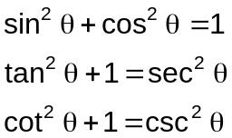

1.10 Functions of Complementary Angles

B

c a

A b C

By referring to the definitions of the trigonometric functions, for the acute angle B,

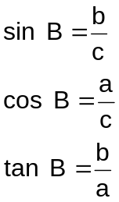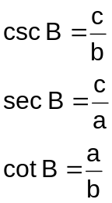

Comparing these formulas with the formulas in 11.7, and making use of the fact that A and B are complementary angles (i.e. A + B = 90°), then:

sin B = sin (90° - A ) = cos A
cos B = cos(90° - A ) = sin A
tan B = tan (90°- A ) = cot A
cot B = cot (90° - A ) = tan A
sec B = sec (90° - A ) = csc A
csc B = csc (90° - A ) = sec A

The relations may then be expressed by a single statement: Any function of the complement of an angle is equal to the c-function of the angle.

Example 1.10.1 Express each of the following in terms of its cofunction:

a) sin 76° c) cos 39°23’
b) csc 80°35’32” d) tan ( A + 15°)

Example 1.10.2 Determine the value of that will satisfy the following:

a) 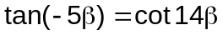 c) 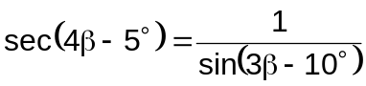
b) 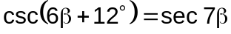 d) 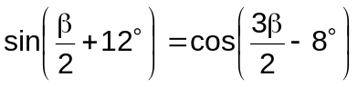

1.11 Trigonometric Functions of Special Angles 45°, 30°, 60°

To find the functions of 45°, construct an isosceles right triangle. It is convenient to make each equal sides be 1.

B
By Pythagorean Theorem,
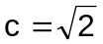 a = 1

45°
A C
b = 1

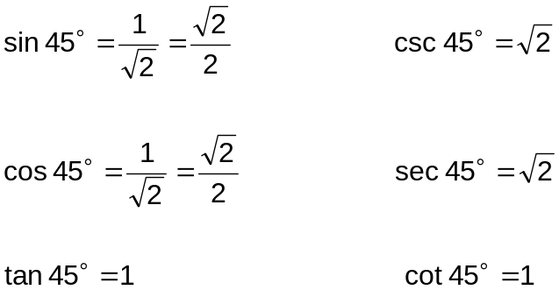

To find the functions of 30° and 60°, take an equilateral triangle. As shown in the figure, draw the bisector of one of the angles. This bisector divides the equilateral triangle into two congruent right triangles whose angles are 30° and 60°. Consider one of these, namely ABC, If each side of the original equilateral triangle is 2 units in length, it follows that in ABC, c = 2, and b = 1. Then

B

30°

c = 2
a =

60°
A
b = 1 C
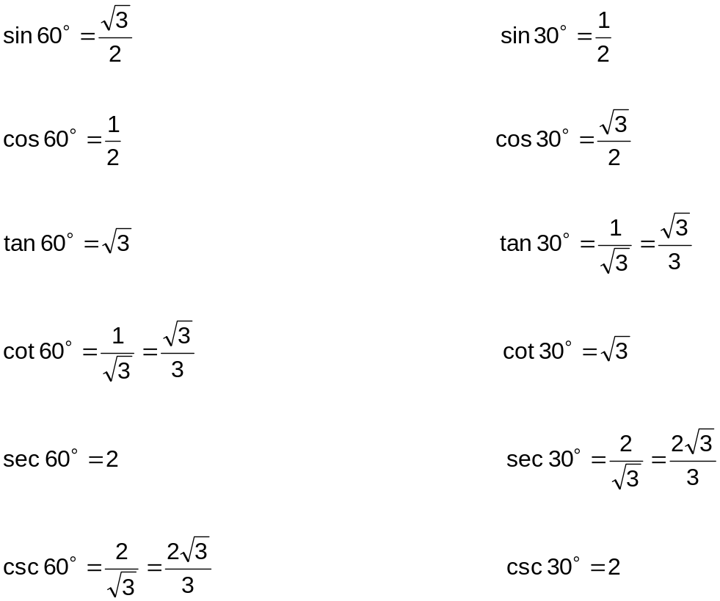

Example 1.11 Without the aid of the calculator, evaluate the following:

- 3 tan² 60° + 2 sin² 30° - cos² 45°

- 5 cot² 45° + 5 tan 45° + sin 30°

- cos² 60° - csc² 30° - sec 30°

- tan 60° + 2 cot 30° - sin 60°

- tan⁵ 45 + cot² 45° - sin⁴ 60°

